Welcome to the Central Access Reader!

Press the Space bar to start playing back speech.

This tutorial will help guide you through the basics. You can always access this tutorial in the Help Menu, or by pressing Ctrl H on your keyboard.

# Opening a Word Document

Open a Word Document in the File Menu, or by pressing Ctrl O on your keyboard.

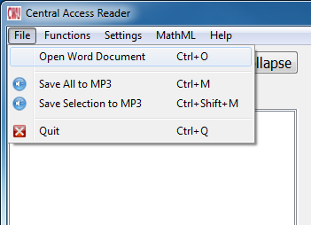

# Start and Stop Reading

Read Button. (Keyboard shortcut: Windows, Ctrl R; Mac, Command R).: Press to start at the current highlight, or drag the mouse to highlight the text you wish to have read.

Stop button. (Keyboard shortcut: Windows, Ctrl S. Mac, Command S): Press to stop the reading at any time.

You can also press the Space bar to start and stop reading.

# Settings

## Speech Settings

Speech Settings Button. (Keyboard shortcut: F1).

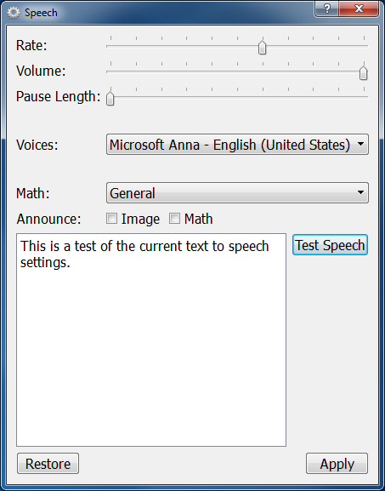

Select if you want images and math equations verbally introduced. For example, if selected, an image would begin with the reader announcing "Image." After the alternate text is read, the image would end with "End Image."

You can also view alternate text by placing your cursor over the image.

## Highlight, Color, and Font Settings

Color Settings Button. (Keyboard shortcut: F2).

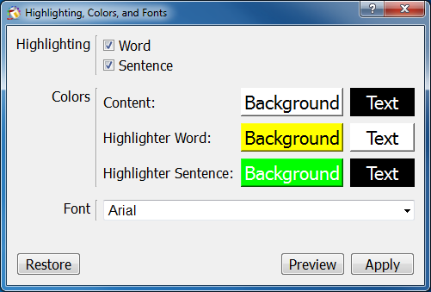

Enable highlighting by word and sentence as it is read. Dual-highlighting is enabled by default.

Change the colors of the background and text in the document.

Change the font type. Preview changes, apply changes, or restore to software defaults.

## Adjusting Text Size

Zoom In Button. (Keyboard shortcut: Windows, Ctrl =. Mac, Command =)

Zoom Out Button. (Keyboard shortcut: Windows, Ctrl Minus. Mac, Command Minus)

Press the Zoom In or Zoom Out buttons to increase or decrease text size.

You can also hold down Ctrl and the scroll wheel to quickly zoom in and out.

# Navigating the Document

## Navigation by Keyboard

Use the left and right arrows to move the highlight forward and backwards in the paragraph.

Use the up and down arrows to move the highlight to the previous and next paragraphs.

The Home key brings the highlight to the start of the paragraph, while the End key brings the highlight to the end of the paragraph.

Finally, the Page Up key brings the highlight to the last heading or page while the Page Down key brings the highlight to the next heading or page.

## Navigation Pane

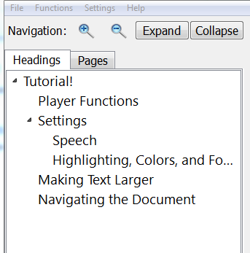

Navigate headings by selecting the "Headings" tab.

Navigate pages by selecting the "Pages" tab.

Select a heading or page, then press the Read Button. (Keyboard shortcut: Windows, Ctrl R. Mac, Command R)., or the Space bar.

Visit the Central Access website to learn how you can prepare your Word Documents to navigate by heading and page at <www.cwu.edu/central-access/reader>

## Navigation by Mouse

Click and drag the mouse to make a selection, then press the Read Button. (Keyboard shortcut: Windows, Ctrl R. Mac, Command R)., or the Space bar. The speech playback will start playing from the beginning of the selection.

You can also double-click a word to quickly set a selection.

# Save to MP3

Save To MP3 Button. (Keyboard shortcut: Windows, Ctrl M. Mac, Command M).

Save the speech of your entire document or to MP3 by using the Save to MP3 button, which can also be found in the File Menu.

To save a specific selection of the document to MP3, simply highlight the desired text and save to MP3.

# Reading Math Equations

For documents with MathType or Microsoft Equation Editor math equations, the Central Access Reader can read them in prose. You can select them like you would with normal text. However, the Central Access Reader cannot read portions of math equations, instead forcing the entire equation to be read.

Try it out on the sentence below:

To find the roots of a quadratic equation of the form , one can use the Quadratic Formula, which is the following: .

Make sure to select the type of math prose to be read in Speech Settings. The Central Access Reader can read General Math, Calculus, Geometry, Trigonometry, Linear Algebra, Logic, and Statistics.

